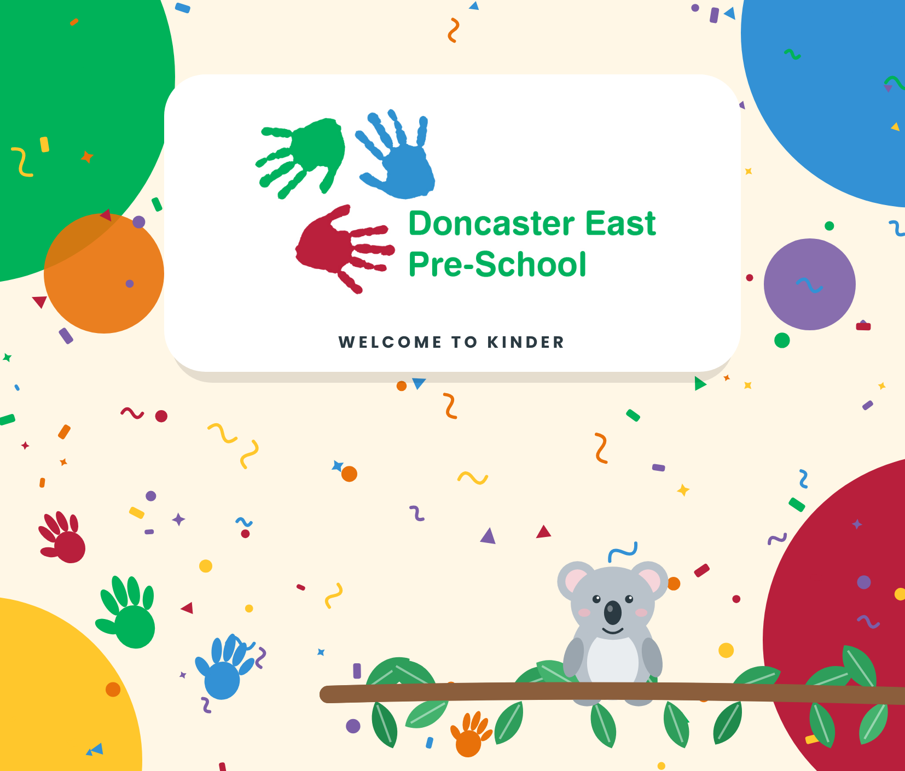
Information Booklet
3-Year-Old Kindergarten
Koala Group • 2027
www.doncastereastpreschool.com.au
ABN: 29060607460 Incorp. No. A10153
4 Montgomery Street, Doncaster East VIC 3109
9842 1409 / 0490 059 225
doncaster.east.kin@kindergarten.vic.gov.au

Doncaster East Pre-School acknowledges the support of the Victorian Government

HELLO AND WELCOME  Welcome to Doncaster East Pre-School | 

3-Year-Old Koala Group
Kindergarten Session Times for 2027
 Session Times  Monday 8.30am – 12.30pm  Tuesday 8.30am – 2.00pm  Thursday 8.30am – 2.00pm |  |  Your Koala Team  Kindergarten Teacher  Fiorella Varrasso  Educator  Selika Harris  Educator  Jade Boyhan

 Term Dates 2027
TERM 1  Thursday 28 January – Thursday 25 March |  | TERM 2  Monday 12 April – Friday 25 June |  | TERM 3  Monday 12 July – Friday 17 September |  | TERM 4  Monday 4 October – Friday 17 December

What’s inside
1  Welcome to Kinder | 2  Your Child at Kinder | 3  Health and Safety | 4  Enrolment and Fees | 5  How We Communicate



Welcome to Kinder
We are delighted to welcome you and your child to our kindergarten community. Four-year-old kinder is a special and exciting time for children and families. Our team works hard to make kinder safe, welcoming and supportive, so every child feels valued.
Our four-year-old group has 28 children. They attend 3 sessions each week with a qualified kindergarten teacher and two experienced educators. We help children feel trusting and confident, and we work with families to make our program welcoming, engaging and inclusive.
At Doncaster East Pre-School we aim to provide a warm and caring place for children and families. We believe children learn best through play, and that the early years are a time of exploring and discovering.
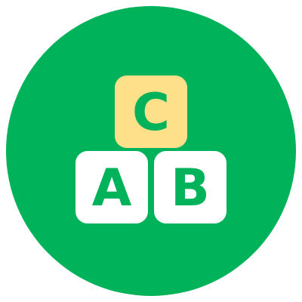 | Our program balances play that children choose, supported play and intentional teaching. We care about each child’s needs, interests and enjoyment as much as learning goals, so kinder is both purposeful and fun. Activities suit each child’s stage of development, background and way of learning. Children try open-ended, hands-on, visual and listening activities. They solve problems, think creatively, communicate and become more independent.

Learning is guided by the Early Years Learning and Development Framework. We observe, plan, document and evaluate in an ongoing cycle. We see children as capable, curious and active learners, and we support their growth and development.
Our program helps children connect with nature. They play outdoors, garden, and join our Bush Kinder program in Kangaroo group. Through this they notice the seasons, stay active and explore natural places such as our garden and local parklands. We also teach sustainable habits every day. Children care for our vegetable garden, sort rubbish and recycling, feed our worm farm and reuse materials creatively.
Every child is a unique individual with their own needs, strengths and interests. Families are always welcome. We build positive relationships with families and the local community. We respect diversity, inclusion and equity, and we embrace the multicultural society we live in.
We believe all children are competent and capable learners, and this shows in everything we do. If you have questions or concerns about your child’s learning, development or the program, please talk to your child’s teacher at any time.

SECTION 2  Your Child at Kinder | 

Pre-School Age Entry Requirements
Your child can join our waiting list at any time after their first birthday. To attend three-year-old kindergarten, your child must turn 3 by April 30th in the year they attend. This is because of government regulations and funding requirements.
Similarly, to attend four-year-old kindergarten, children must turn 4 by April 30th in the year they attend. Because of regulations and child-staff ratios, children cannot attend until their 3rd birthday.

 Settling into Kindergarten
Starting four-year-old kinder is exciting. It is a big milestone for your family. Some children will have been to three-year-old kinder or childcare. For others, it is their first time away from their family.
To help children settle, we make the group smaller during the information session, and we shorten the time at kinder in the first few weeks of term. This means:
- Staff and children get to know each other better.
- Each child gets more one-to-one attention.
- The environment is more relaxed while children get used to their new teachers and friends and explore their new space.
Children who start outside the first few weeks of Term 1 follow a similar routine. They come to an orientation session with their parents. They meet the teacher and explore the space while we complete the necessary paperwork.
Children who start later in the year will attend the last three hours of their first session. This lets them join a settled group, play, have lunch and take part in the end of session routine. The teacher will then slowly increase this time over the next few sessions, in a way that suits each child and family.
Some children will settle quickly, and others will need more time. It is normal for both children and parents to feel anxious at the start of the year. To help your child adjust:
- When you arrive, help your child settle into an activity they like.
- Once they are busy, tell them it is time for you to go and that you will be back to pick them up. Please say goodbye. Sneaking off when your child isn’t watching will only unsettle them more.
- Keep goodbyes short. Say goodbye once and leave. Lots of goodbyes can be stressful for you both.
- Look happy and stay positive, even if you feel sad.
- You are welcome to stay until your child is familiar with the room and teacher. The teacher will suggest when it is a good time to leave.
If your child is unsettled in the first few days, you are welcome to stay and play while they get used to their new environment. Please talk with the teacher about how to begin separating and settling. Every child is different, so we are flexible. Some children cry when their parents leave, but often they stop soon after and enjoy their time at kinder.
If a child is upset when parents leave, staff will contact you to say when they settle, or if you need to come back early. Staff will also ring you if a child becomes distressed during a session.
 | You are welcome to call us at any time with concerns or questions about your child.

Arrival and Departure
When you drop your child off, please sign them in on the attendance register. Because of child-staff ratios and regulations, children cannot be left until the session begins, when staff open the door and greet families. Please don’t sign your child in before the session starts.
When you collect your child, please sign them out on the register. Write the exact time, even if you pick up early or are running late. This is a regulatory requirement.
If you are running late, please call us so we can reassure your child that you are on your way. Waiting can be very distressing for children.
Please note that the kindergarten charges a Late Fee of $1 per minute.

If there is an emergency and you can’t collect your child, please arrange for an Authorised Emergency Contact (Authorised Nominee) to collect them. Staff are only employed for ½ an hour after a session. If your child is not collected within this ½ hour, the late fee rises to $5 per minute and police will be notified to collect your child.
Only people authorised on your enrolment form can collect your child. You can add Authorised Emergency Contacts (Authorised Nominees) to your child’s enrolment information at any time during the year.
If you or an authorised person can’t collect your child in an emergency, please phone the kindergarten with the details of an authorised person who will collect them.
 | A child cannot be collected by anyone under the age of 16 years.

 What Does My Child Need to Bring to Kinder?
A medium sized bag or backpack, large enough to carry:  - A spare set of clothes, including underpants and socks  - Extra clothing for the weather, such as a raincoat and gumboots  - A lunch box with a healthy snack and a healthy lunch, including fresh fruit and/or vegetables  - A drink bottle with water only  - Please label all containers and drink bottles with your child’s name. | 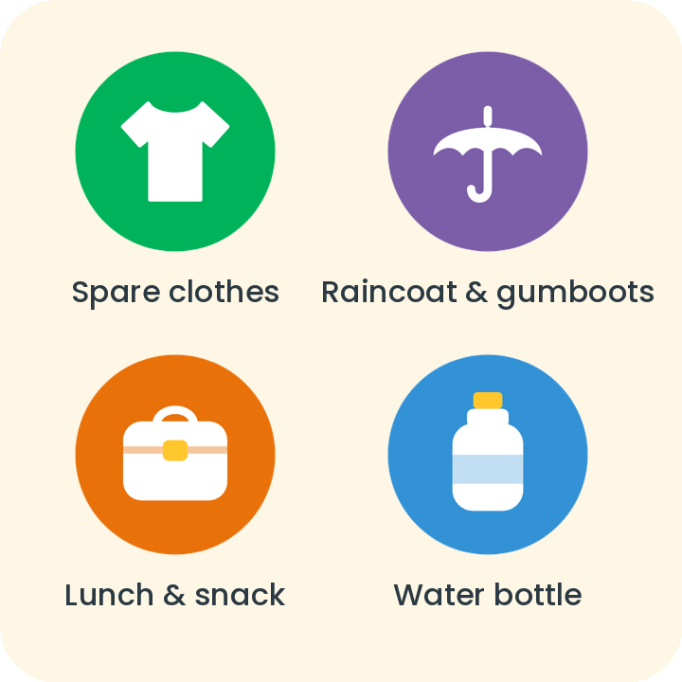

Doncaster East Pre-School is an ALLERGY AWARE pre-school. Some children have serious allergies, and many of these are nut allergies. NUTS are NOT to be brought into the pre-school.

 What Should My Child Wear to Kinder?
Please send your child in comfortable clothes that are good for play and that they can manage themselves. For example, clothes they can take off easily when going to the toilet. Please clearly name all clothing. You can also buy our DEPS logo clothing (t-shirt and jumper) from eduthreads.com.au/collections/doncaster-east-pre-school.
Thongs, crocs and slip-on shoes are not allowed. They are dangerous and awkward for climbing and running. Closed-toe shoes or sandals with straps are better, and gumboots are good for rainy days.
When it is cool, please send a warm waterproof coat or jacket with a hood (or a raincoat) and a winter hat. We offer our outdoor program all year round. Even when it rains, children can use our undercover outdoor areas, so they need to be dressed for the weather.

 Birthday Celebrations
We acknowledge and celebrate children’s birthdays at Doncaster East Pre-School. Some families like to bring a treat to share. Because many children have different allergies, staff and management have decided that cake sharing may not be appropriate. If you would like to bring a treat, please bring a plain chocolate frog for each child (children with allergies will be given an alternative). There are 28 children at each kindergarten session.
We use a pretend cake with real candles to sing happy birthday to every child during the session. If you would prefer, we don’t celebrate your child’s birthday at kinder, please speak to the kindergarten teacher.

 Excursions, Incursions and Special Events
During the year we organise special experiences for the children, such as incursions, excursions and special days. These add to the learning program and give children new experiences.
The cost of these events is not included in the government funding for Free Kinder, so families may be charged directly. We will send an invoice with due dates and payment instructions. Please pay by the due date. Refunds are not given if your child is away on the day of an event.

 Toys from Home
We recommend children leave toys at home, so they don’t get lost or damaged. If a child brings a toy to kinder, they will be asked to keep it in their bag. The kinder is not responsible for lost or broken toys brought from home.

SECTION 3  Health and Safety at Kinder | 

 Safety
For your child’s safety, please make sure the front gate is shut securely straight after you, your child, or any children in your care enter or leave. While arriving or leaving, please watch that other children don’t go out of the gate without an adult.

If you arrive early, please wait outside the front gate until staff open it at the start of the session. Parents and carers must not leave the grounds until their children have been signed in.
Once your child is signed out, you are responsible for their safety. Please leave the grounds promptly after pick-up to keep everyone safe.

 Snack and Lunch Times at Kinder
In three-year-old sessions we have snack and lunch with the children, except on Mondays, when we have an afternoon snack only.
We offer progressive snack between 10–11am or 2:30–3:30pm. This means children eat when they get hungry, without interrupting their play. Snack times are flexible, but every child will eat snack each session.
On Tuesdays and Thursdays, we pack up around 12.45pm and have lunch together as a group, usually between 1.00pm and 1.30pm.
When packing snack and lunch, please label all containers and make sure your child can open them easily. They will need:
 | Drink Bottle: Please bring a drink bottle filled with water. Your child can drink from it at any time during the session.
 | Snack: Please bring a healthy snack that includes fresh fruit and/or vegetables, plus something small, for example cheese and crackers, yoghurt or rice cakes.
 | Lunch: Please bring a healthy lunch. Ideas include a sandwich, wrap, sushi, rice or pasta. It is also a good idea to pack an extra piece of fruit in case your child is still hungry after lunch.

We encourage healthy eating and ask families to provide nutritious food for their children. Foods high in sugar and/or fat, such as chips, lollies, roll-ups and chocolate, are not recommended. Please note that we do not refrigerate or heat food at kinder.
We are an ALLERGY AWARE pre-school. This means nuts, or foods with traces of nuts, are NOT to be brought to pre-school at any time. Some children here are highly allergic to nuts, and contact with nuts or nut products could be fatal. If your child eats nuts, or foods containing nuts or traces of nuts, before kinder, please make sure they wash their hands, teeth and face before they come.

 Illness and General Health
Please keep unwell children at home. Viruses and infections spread easily in groups of children. You are the best judge of whether your child is well enough for kinder, not your child. Children often say “I’m ok” because they love kinder, so please decide using the facts. If they have been unwell, are very tired or have a temperature, please keep them home. Sick children won’t enjoy kinder, and we are sure you would want sick children kept away from your healthy child, so please offer other parents the same courtesy.
By law, we must follow the minimum exclusion period for illness recommended by the Department of Health. This is how long a person with an infectious disease must stay away from a children’s service to stop it spreading. You can see the Department of Health’s exclusion table at the kinder, or at (http://docs.health.vic.gov.au/docs/doc/Minimum-Period-of-Exclusion-from-Primary-Schools-and-Childrens-Services-Centres-for-Infectious-Diseases-Cases-and-Contacts)
If a child becomes ill at pre-school, we will try to contact parents to arrange pick-up. If we can’t reach parents, we will contact the emergency contact or the child’s own doctor.
 | Children with asthma, allergies or other ongoing medical conditions that need medication must have an ‘Action Plan’ written with your General Practitioner. It must be given to the centre before your child starts. This is a condition of enrolment. If you need a blank ‘Action Plan’, please visit www.asthmaaustralia.org.au or www.allergy.org.au. Your child cannot start kindergarten until we have the original full colour action plan signed by your GP.

 Being Sun Smart at Kinder
Doncaster East Pre-School is an accredited ‘Sun-Smart Centre’. When you enrol, you need to buy a Doncaster East Pre-School sun smart hat online at eduthreads.com.au/collections/doncaster-east-pre-school. The hats are delivered to us, labelled and kept in individual pockets at kinder all year. Children wear them between September and April, and on any day the UV rating is over 3.
We go outside during every session. Please put sunscreen on your child before kinder each day during September and April, and whenever the UV rating is over 3. In longer sessions we reapply sunscreen once.

 Emergency Evacuations
We practise our emergency procedures with the children each term. In an extreme emergency, such as a fire or gas leak, where we need to leave the building, children will go either to the park beside the centre or to the McDonalds on the corner of Blackburn & Doncaster Roads. The centre’s Emergency Evacuation Plan can be viewed at the centre.
During an evacuation, parents will be told by SMS and can collect their children from the evacuation point. You must still sign your child out, using EnrolNow SISO, or a paper attendance register if EnrolNow is not available. The kindergarten teacher will take it to the evacuation point.

 Laundry
The kindergarten has no laundry, so once or twice a year we may ask you to take home a few items, such as towels, art smocks and/or dress-ups, to wash and return.

SECTION 4  Enrolment and Fees | 

Enrolment
All families must fully complete an Enrolment Form for their child and submit it before their child can start. The form is on EnrolNow. It includes contact details, information about allergies, immunisation and medical conditions, emergency contacts and more. Please keep this information current. You can update it online at any time. Staff can help if you have difficulty, including giving you hard copy forms.
By law, children cannot attend until the enrolment form is fully completed. This includes up-to-date immunisation records (under the government’s “no jab no play” policy) and any medical condition action plans that are needed.
Every child must also have at least two emergency contact people on their form, and one of them must be local so your child can be collected quickly in an emergency. If you don’t have an emergency contact, please ask another kinder family you feel comfortable with.
All kindergarten records and information are kept confidential under our Privacy Policy, which you can view at the centre or on our website.

 Fees
In 2027 the Victorian Government continues to provide FREE KINDER for all eligible children in a funded kindergarten program, so no term fees apply. Families may be charged for extra costs during the year, including service events such as excursions, which add to the program and support children’s learning and engagement. We will send an invoice with due dates and payment instructions.

Your child can only be funded for a kindergarten place at one service at a time. Your child can be funded for only one year of four-year-old kindergarten, after which they move on to primary school (unless your child’s kindergarten teacher assesses them as eligible for a second funded year). You can view our Fees Policy at the centre or on our website.
PLEASE NOTE: Free Kinder funding is an extra payment to services to cover the parent fee. It is paid on top of other kindergarten funding (except Kindergarten Fee Subsidy (KFS), KFS Ratio Supplement and Early Start Kindergarten (ESK)).

 Kindergarten Fee Subsidy for Eligible Families
Children in a funded four-year-old kindergarten program may be able to get lower fees if they, or their parents/guardians, hold a current approved concession card. This follows government policy and funding rules, and we must keep a record.
If you hold an approved concession card, you must make sure the Nominated Supervisor/Director or your child’s kindergarten teacher has seen the original and has a photocopy of the current card before the start of term, to get a fee reduction. For a list of approved concession cards, please see our Fees Policy on our website.

SECTION 5  How We Communicate with Families | 

 Parent Participation
Parent participation is essential for the pre-school to run well each year. Regular contact and sharing information with families is an important part of the kindergarten program and of building our pre-school community.
We strongly encourage parents and family members to join in kindergarten events and activities. You could:
- Become a member of the Committee of Management
- Help with fundraising and social events (e.g. Bunnings BBQs)
- Be a parent helper at stay and play
- Come to special events such as Mother’s Day, Father’s Day, Grandparents and Special Persons Day
- Share cultural and religious celebrations
- Help with kindergarten maintenance (e.g. working bees, assembling or repairing equipment)
- Review grant submissions, policies and procedures

 Committee of Management
The Committee of Management is made up of parent volunteers. It oversees the running and management of the kindergarten.
A new committee is elected each year at the Annual General Meeting. It is made up of parents at the pre-school and includes:
President |  | Vice President |  | Secretary
Treasurer |  | Social Events Co-Coordinator |  | Fundraising Co-Coordinator
Policy Officer |  | Grants Officer |  | Maintenance and Working Bee Officer
Kinder Kapers Editor |  | Class Representatives |  | General Members

We have many procedures to support the committee. Our centre director and administration officer help make sure the paperwork for running the centre is completed and submitted on time, and that policies and procedures are in place for the smooth running of the kindergarten. They also help manage enrolments, prepare the budget and meet other legal requirements. Doncaster East Pre-School is also a member of the Early Learning Association Australia (ELAA), which supports and guides committee members and can answer any question about running the centre.
Please consider joining our committee. Volunteering has many benefits:
- You can contribute to what happens at the pre-school.
- You help the pre-school run smoothly, for example by appointing and supporting staff, reviewing policies and procedures, managing budgets and records, and keeping up to date with legal and ethical requirements.
- You can build skills such as meeting skills, procedures and marketing.
- You get to know other parents, which can help your child form friendships too.

Storypark
To record children’s learning and help families and teachers communicate, we use Storypark. It is a secure, private, cloud-based tool.
We use Storypark to:
- Help parents be part of their child’s day wherever they are, and extend their child’s interests and learning
- Let teachers share photos, videos and learning stories, and record children’s learning and development for reflection, documenting and planning
- Let teachers and group representatives update parents about special events, incursions, excursions and group social activities
- Let the Pre-School committee share information, including about social events and fundraising for the whole kinder
Our parents enjoy getting photos and updates about what their children do at pre-school, especially while at work or when faced with the usual ‘I can’t remember what we did today.’ The app is also a social tool for chatting with other parents, social activities and arranging community events. Most importantly, it helps our teachers document children’s learning and development more efficiently and effectively.
You will get an email invitation to install Storypark for Families. You can use it on a computer, iPhone, Android device or tablet. It is free. The app is secure and highly encrypted. To find out more visit www.storypark.com.au.

 EnrolNow
We use EnrolNow to help run the pre-school, including waitlist applications, managing enrolment information and signing children in and out.
EnrolNow lets parents:
- Submit waitlist applications, and complete and keep up-to-date enrolment information, including authorised emergency contacts and immunisation records
- Digitally sign children in and out of kinder sessions.

 Newsletters and Communication with Families
Your child’s kindergarten teacher will send newsletters and information by email and Storypark about the four-year-old program and kinder events. We also invite you to follow our Facebook page for regular updates about what is happening at Doncaster East Pre-School and in the local community.
The committee also publishes and distributes a newsletter called “Kinder Kapers”. It keeps parents informed about activities at the centre, social events and news affecting pre-school education across the district or state.

Stay and Play
Each term we draw up a “stay and play” roster, and all parents are invited to choose the day that suits them best. Grandparents, aunts, uncles and caregivers are welcome if parents can’t come.
Parent involvement enriches the program. You can join daily activities, watch your child in the pre-school program, and give staff more chance to work with individual children. Children also feel proud when their parents come to kinder.
While you are here, we may ask you to help with an activity or prepare snack. Mostly, though, you will have time to spend with the children, see your child in the group, get to know their kinder friends and learn about our daily routines.
If you can’t help on your rostered day, it is best to swap with another parent. If you can help in an emergency, or would like to help more often, please tell the staff.


We hope that you enjoy your three-year-old kindergarten year at Doncaster East Pre-School and if you have any further questions in relation to the centre, the program or your child’s development, please do not hesitate to talk to your child’s kindergarten teacher.

